Foundation

Case Study

Name : Sidharth Bansal

Employee code : 655314

Step 1

Creation of Virtual Machine on Azure

1)Select OS

2)Select server size

3)Allow HTTP and SSH

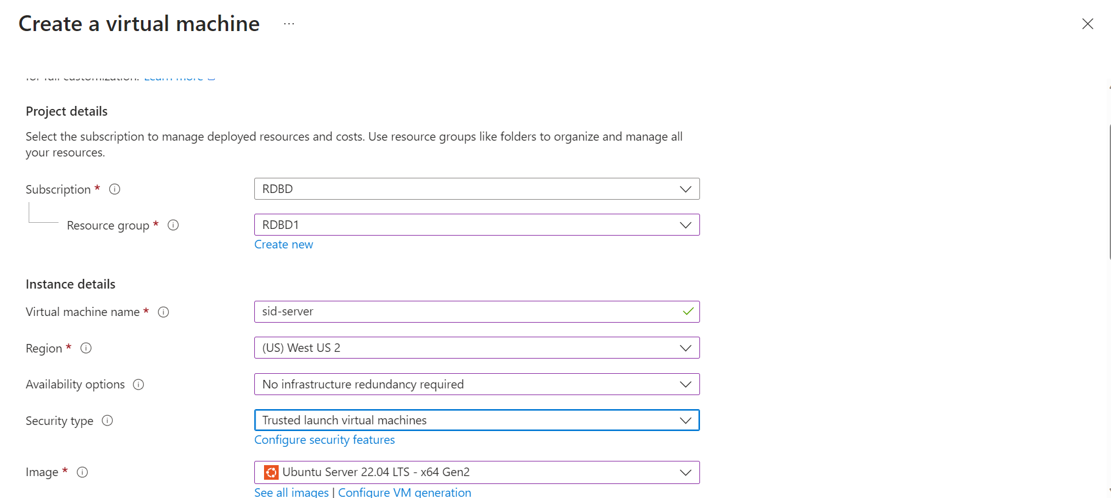

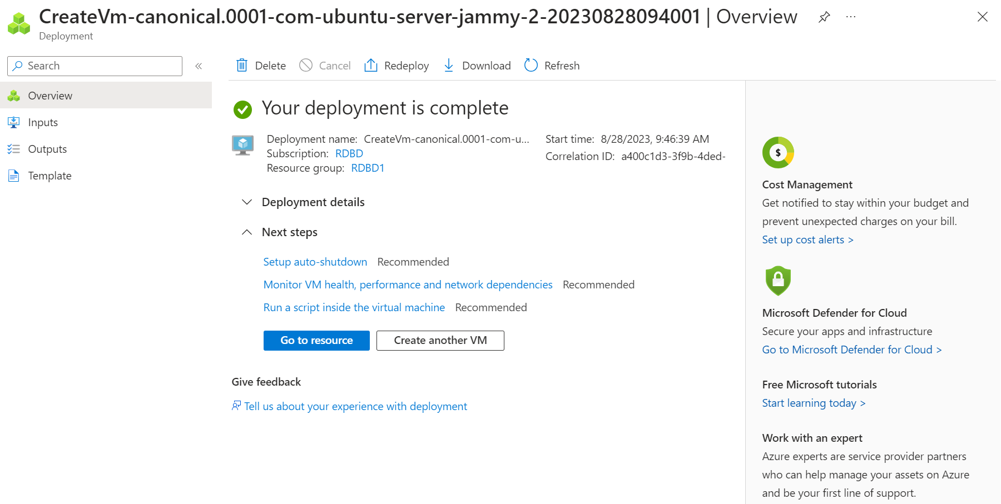

Step 2

Connect to VM using SSH and install Apache Server

1)ssh [sid@20.236.56.188](mailto:sid@20.236.56.188) this command will enable us to connect to the VM

2)run sudo apt update and sudo apt install apache2 -y

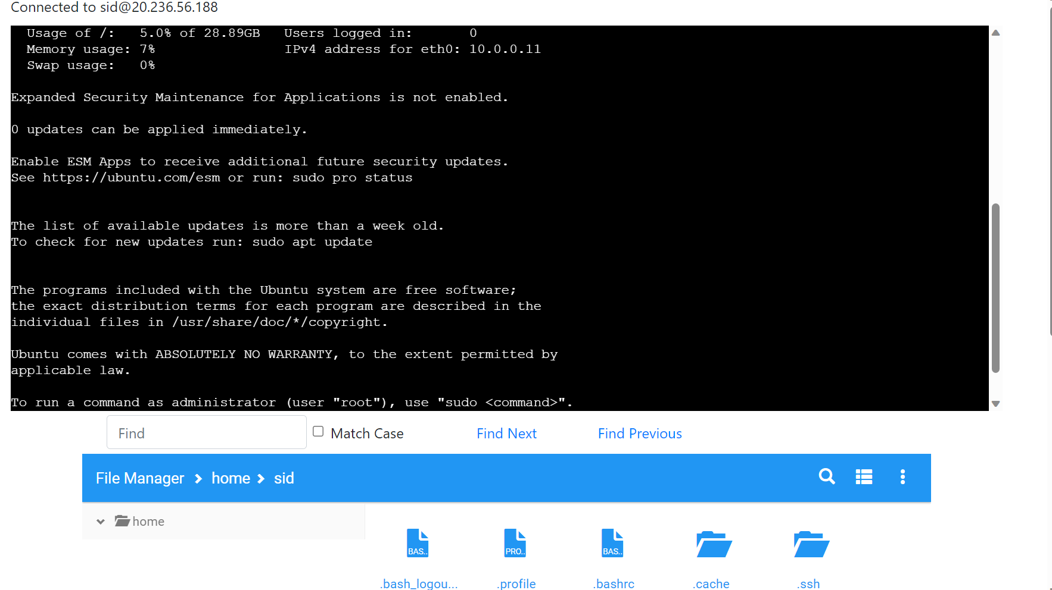

sudo apt update

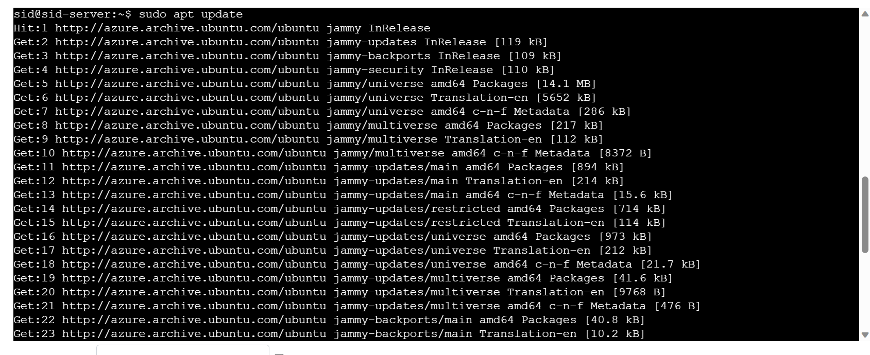

sudo apt install apache2 -y

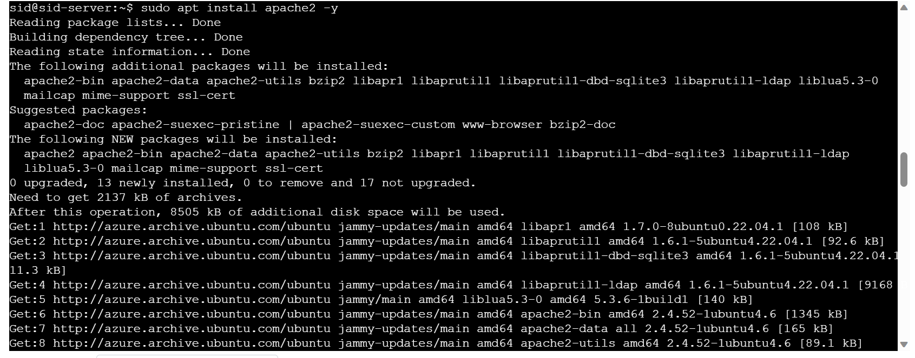

Step 3

Install Docker in VM

1)install gnome-terminal using sudo apt install gnome-terminal

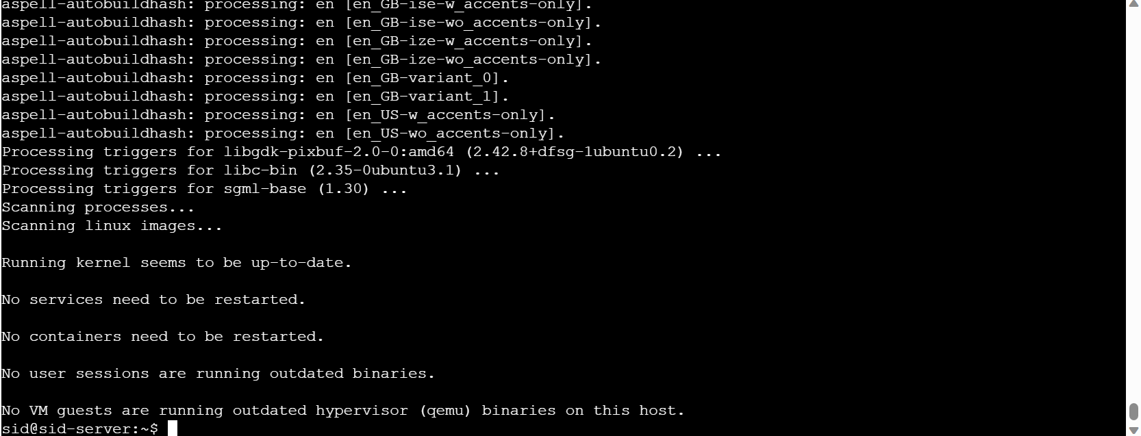

2)run sudo apt remove docker-desktop to uninstall older versions of Docker

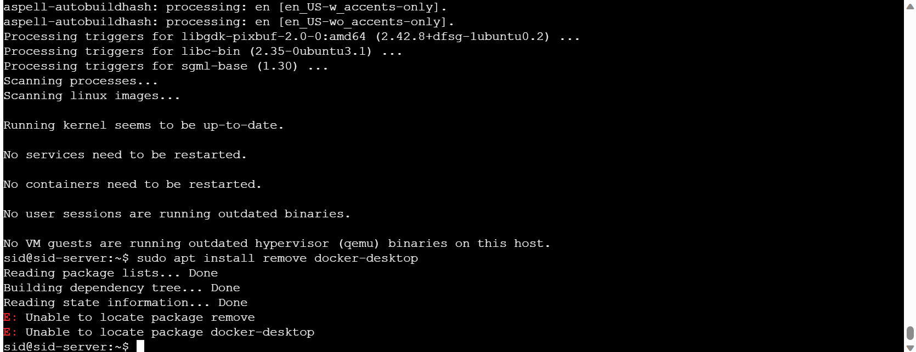

3.1 Setup the repository

3.1.1 run sudo apt-get install ca-certificates curl gnupg

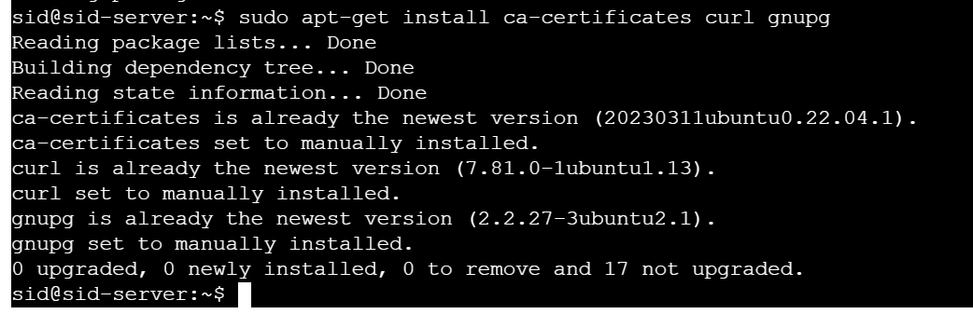

3.1.2 run a) sudo install -m 0755 -d /etc/apt/keyrings

b) curl -fsSL https://download.docker.com/linux/ubuntu/gpg | sudo gpg --dearmor -o /etc/apt/keyrings/docker.gpg

c) sudo chmod a+r /etc/apt/keyrings/docker.gpg

this will add add Docker's official GPG key

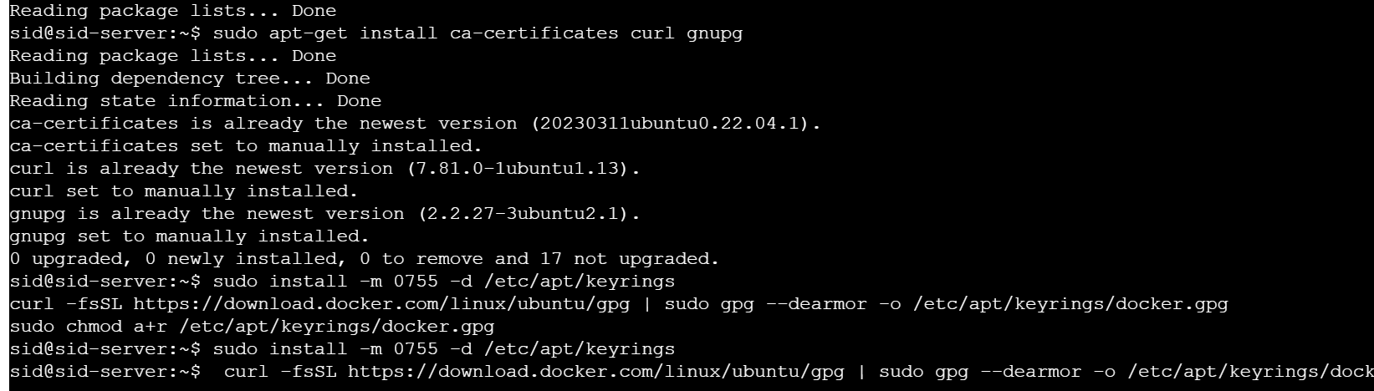

3.1.3 To setup the repository run echo \

"deb [arch="$(dpkg --print-architecture)" signed-by=/etc/apt/keyrings/docker.gpg] https://download.docker.com/linux/ubuntu \

"$(. /etc/os-release && echo "$VERSION_CODENAME")" stable" | \

sudo tee /etc/apt/sources.list.d/docker.list > /dev/null

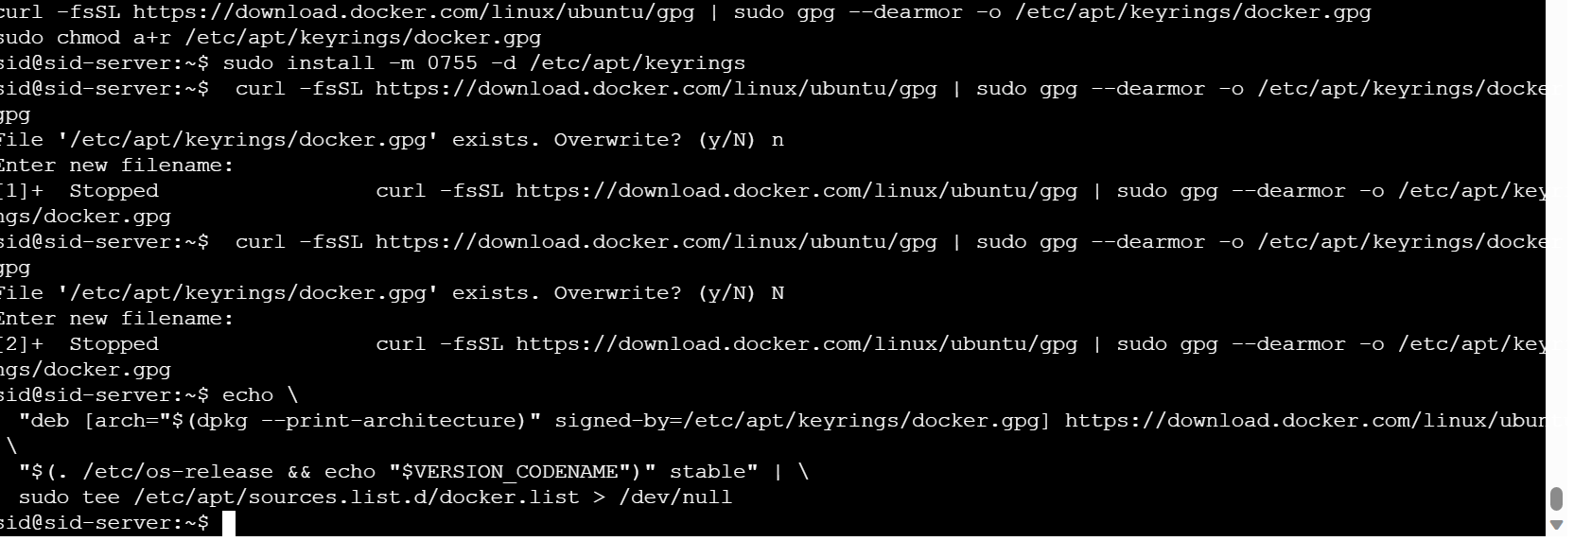

3.1.4 Install latest DEB Package

a)sudo wget https://desktop.docker.com/linux/main/amd64/docker-desktop-4.22.1-amd64.deb?utm_source=docker&utm_medium=webreferral&utm_campaign=docs-driven-download-linux-amd64&_gl=1*6piug0*_ga*MjgzMjYzMTkzLjE2OTMxOTcwNTM.*_ga_XJWPQMJYHQ*MTY5MzE5NzA1My4xLjEuMTY5MzE5NzY4NC42MC4wLjA.

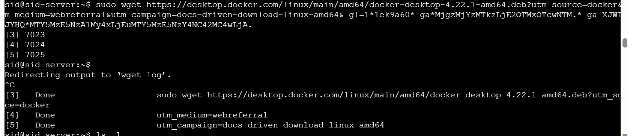

b) sudo mv 'docker-desktop-4.22.1-amd64.deb?utm_source=docker' docker-desktop-4.22.1-amd64.deb

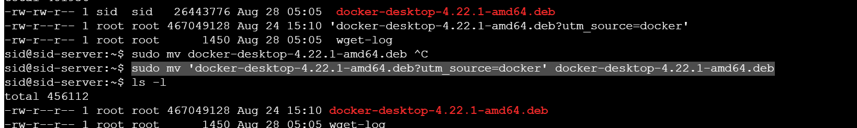

c) sudo apt-get install ./docker-desktop-4.22.1-amd64.deb

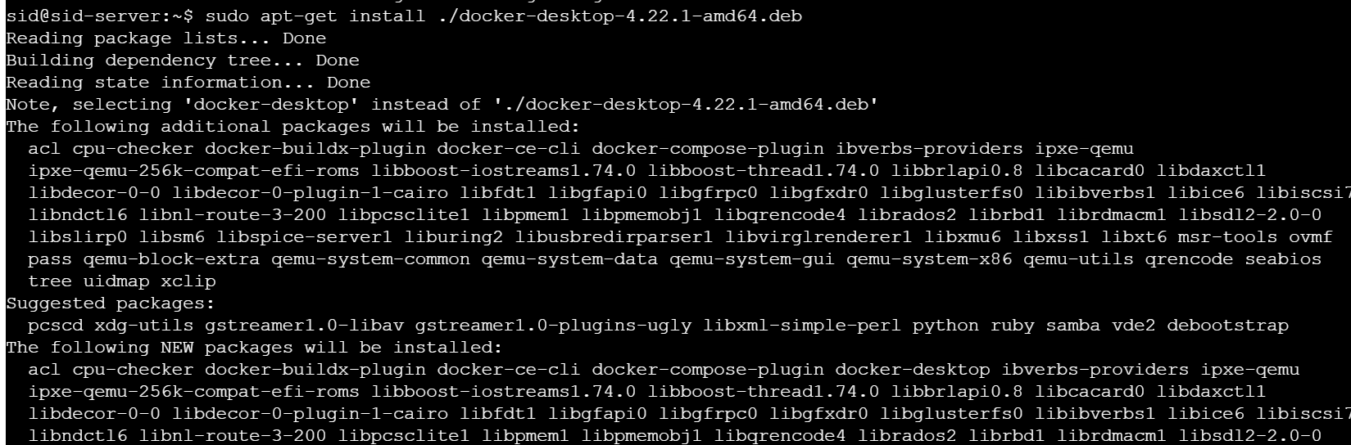

Step 4

Launch Docker Desktop

1)systemctl --user enable docker-desktop

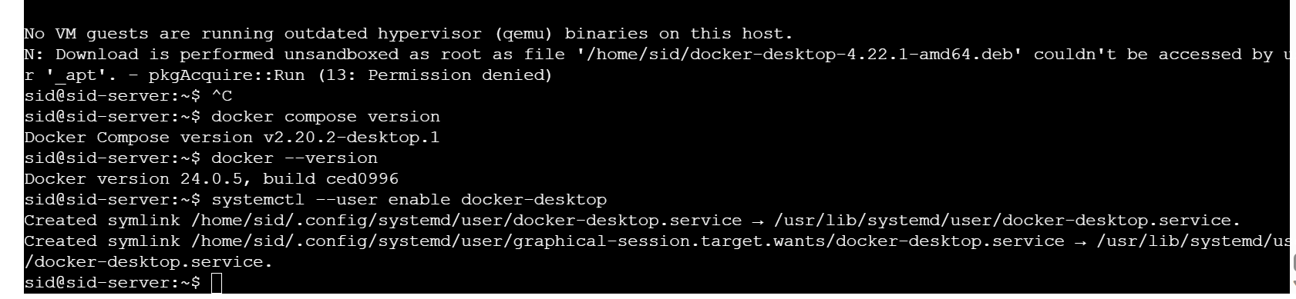

Step 5

Clone Git Repository and save it in VM

1)Create a directory using sudo mkdir myapp

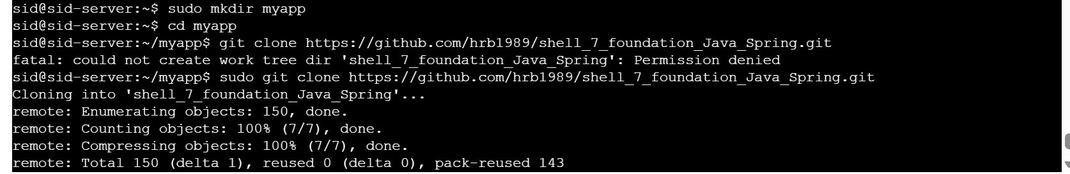

2)Clone the repo in myapp folder using git clone <https://github.com/hrb1989/shell_7_foundation_Java_Spring.git>

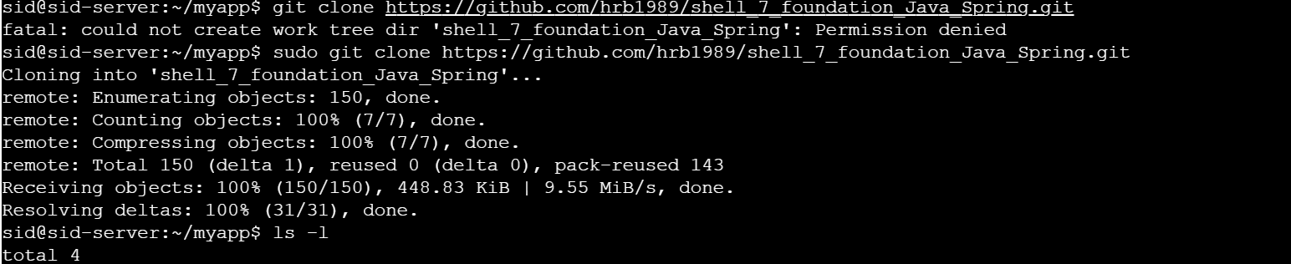

3) cd shell_7_foundation_Java_Spring to get

4) mvn install -DskipTests

5) sudo apt install -y openjdk-17-jdk

6) mvn install -DskipTests

Step 6

Create Docker file and Docker image

1)run sudo touch dockerfile to create docker file



2)run sudo vim dockerfile to write the instructions

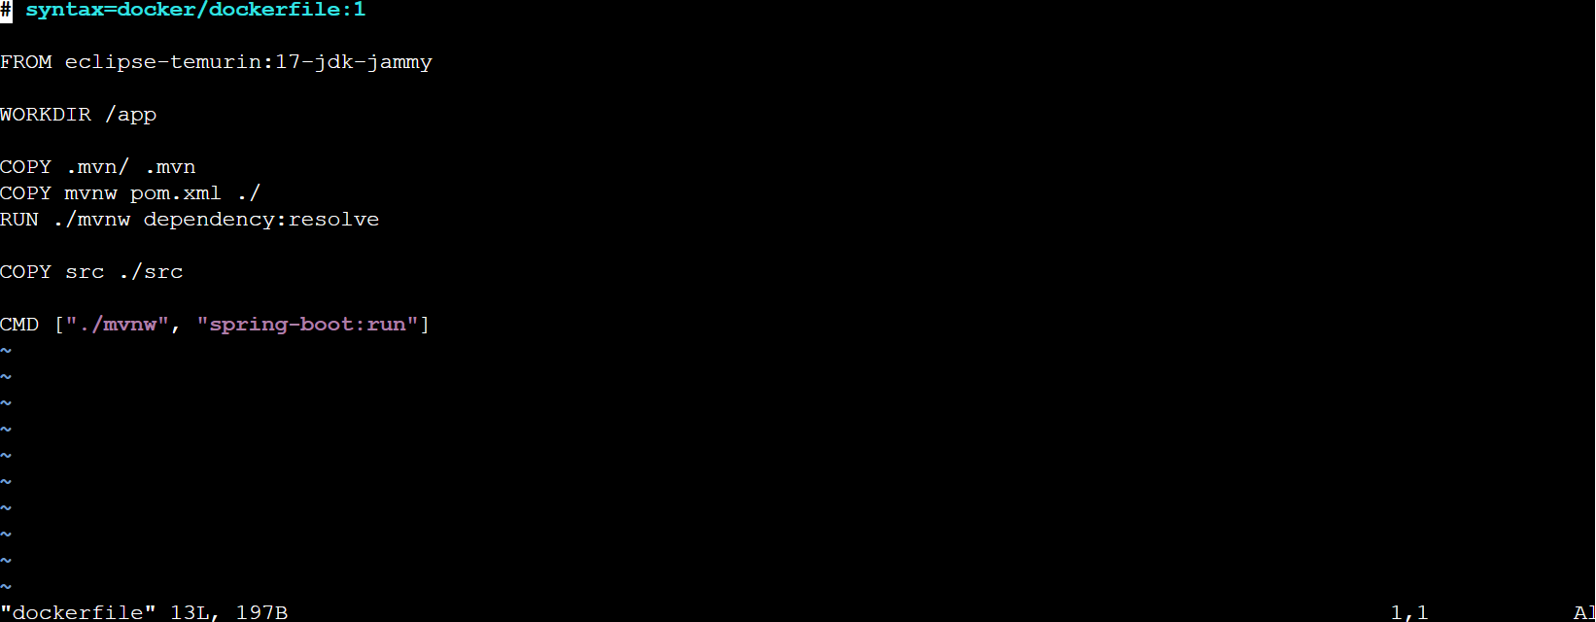

3) To make docker image run sudo docker build --tag java-docker .

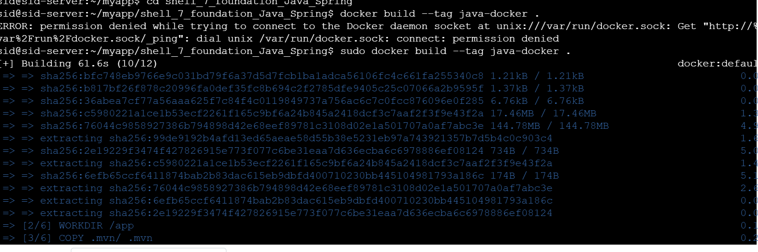

4)To verify if the docker image has been created run sudo docker images

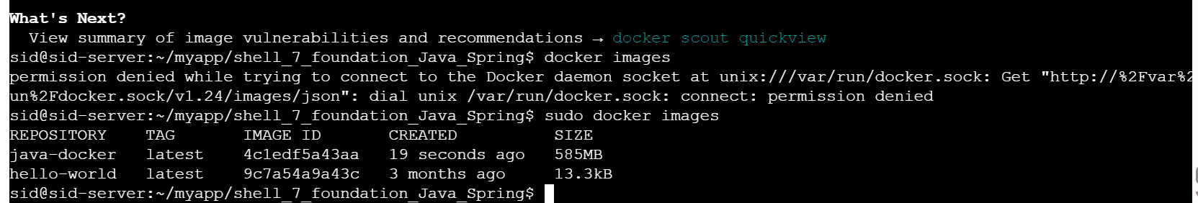

Step 7

Push the docker image to docker hub

1)create docker account

2)Create repository in docker hub

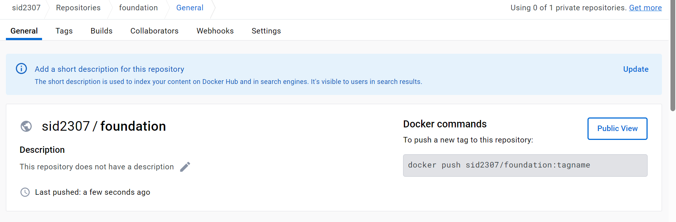

3)login in docker hub through terminal using sudo docker login -u sid2307

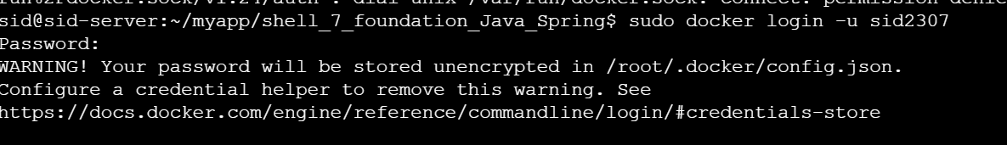

4)Push to image to docker hub in the created repository using

sudo docker tag java-docker:latest sid2307/foundation

sudo docker push sid2307/foundation

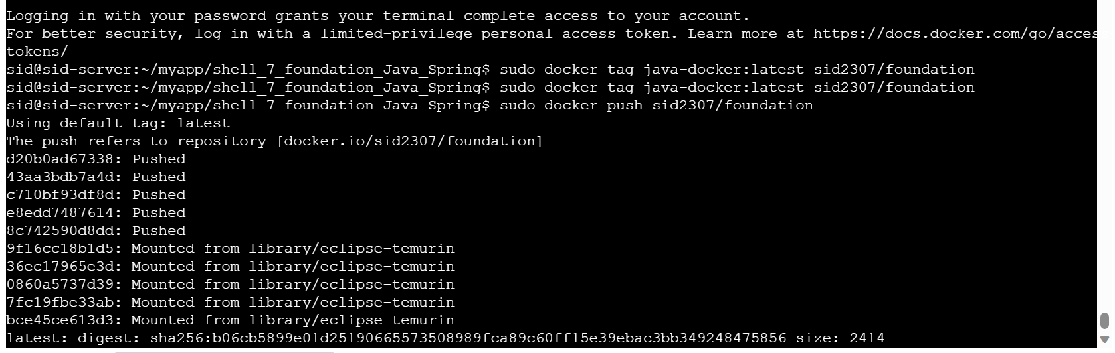

Docker image pushed

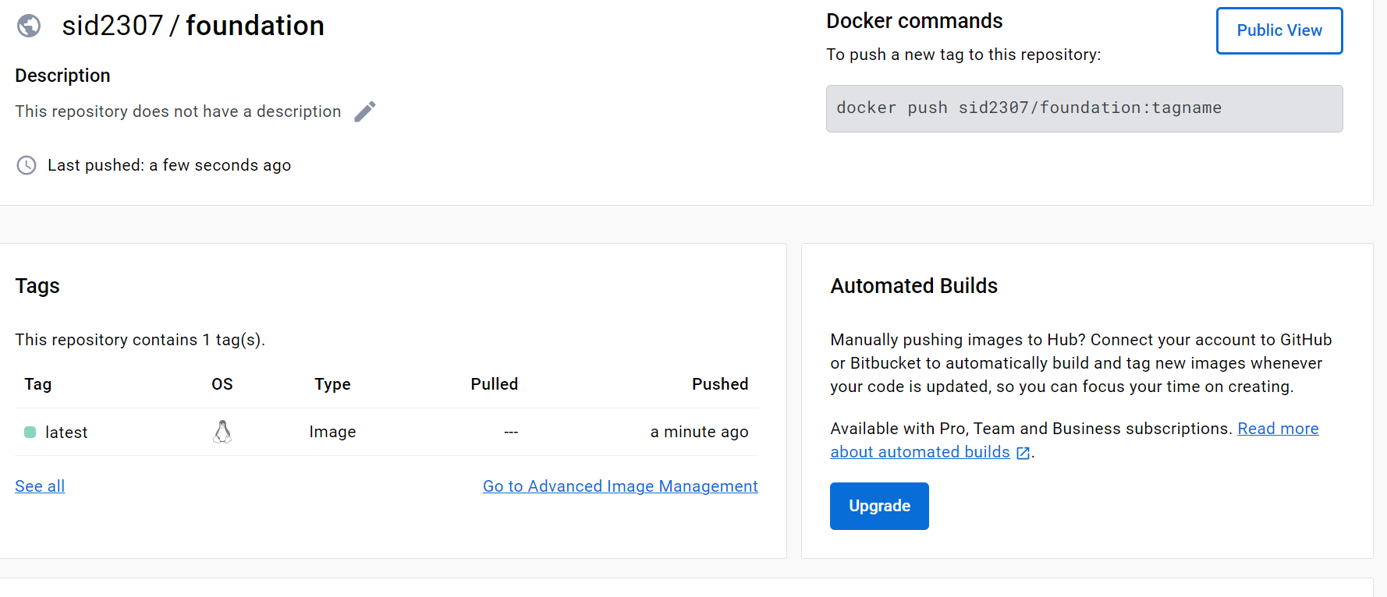

Step 8

Setting up github actions

1)Fork the shell_7_foundation_Java_Spring repository

2)Add a secret in github named DOCKERHUB_USERNAME assign the value as docker id

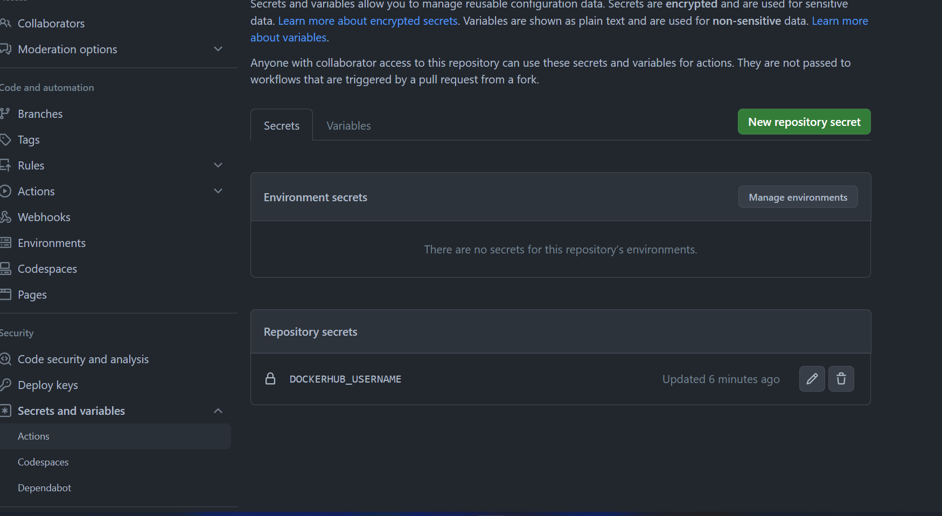

3)Create Personal Access Token for Docker Hub

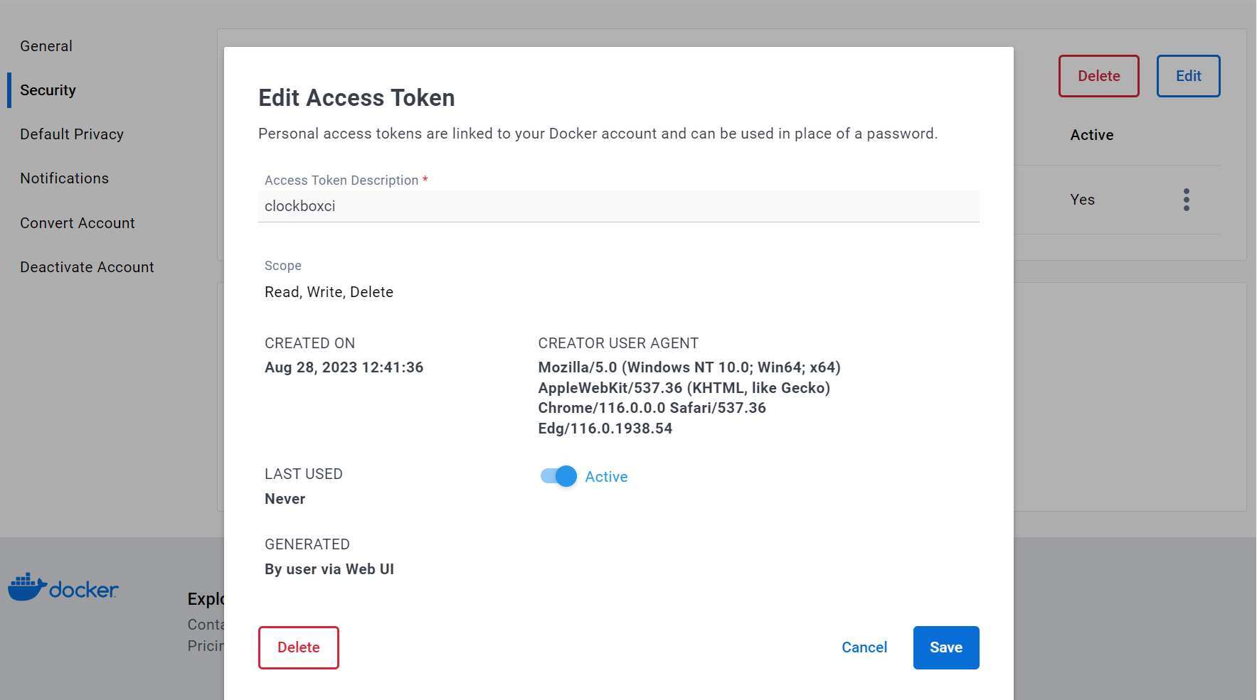

4)Add docker hub secret in github

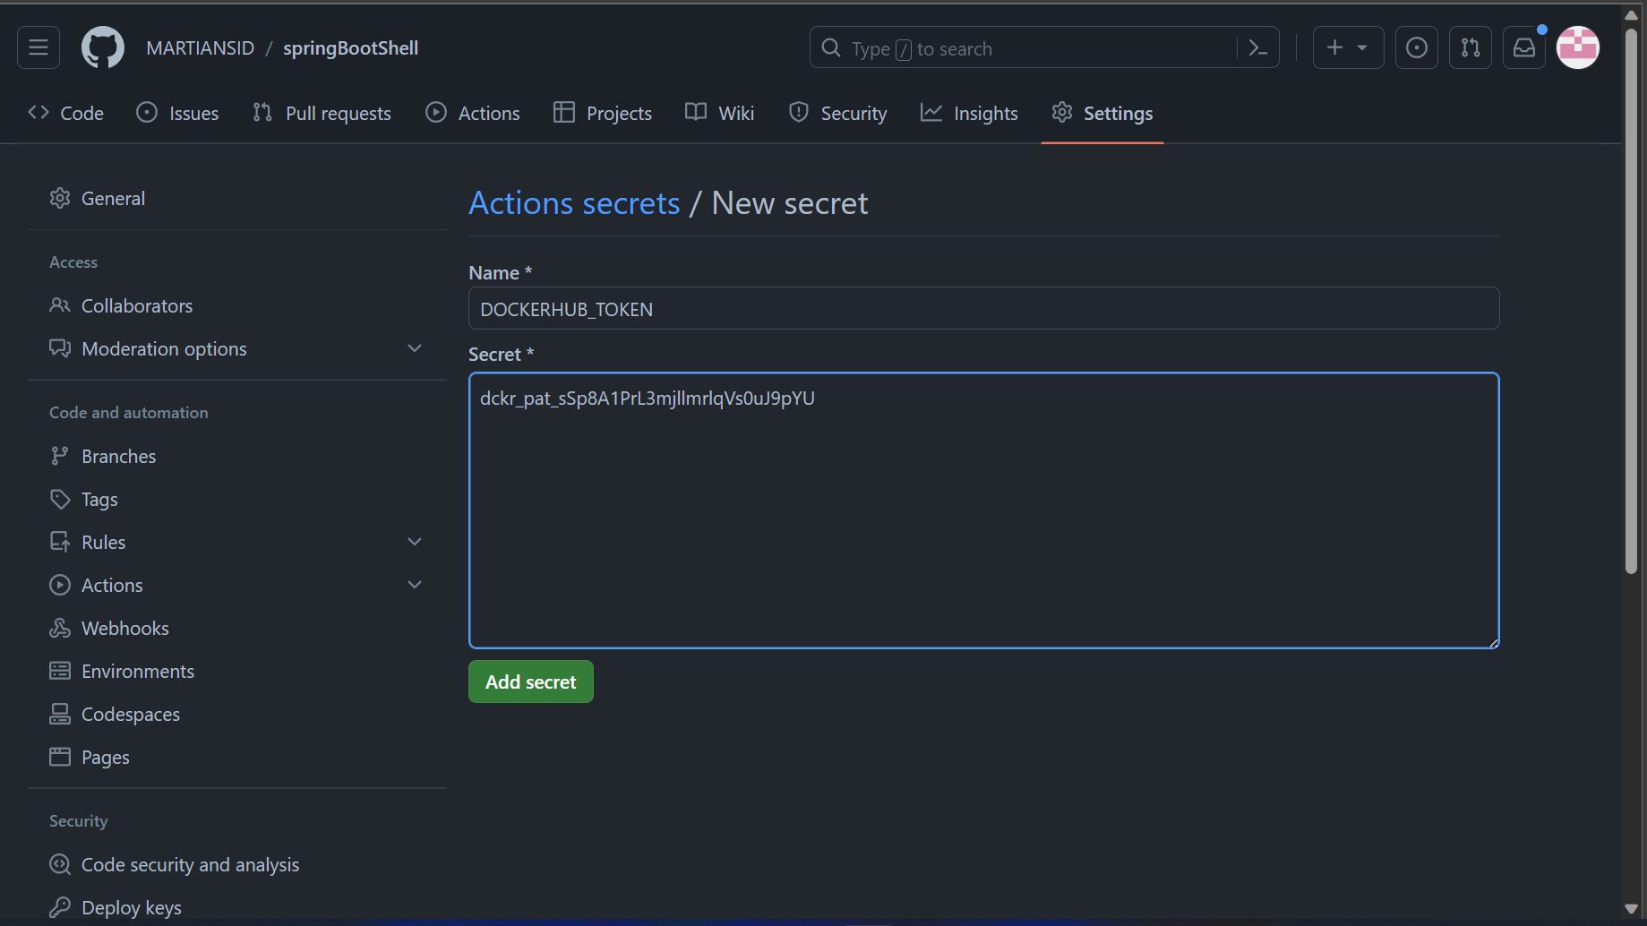

5)Set up github actions workflow for the repository

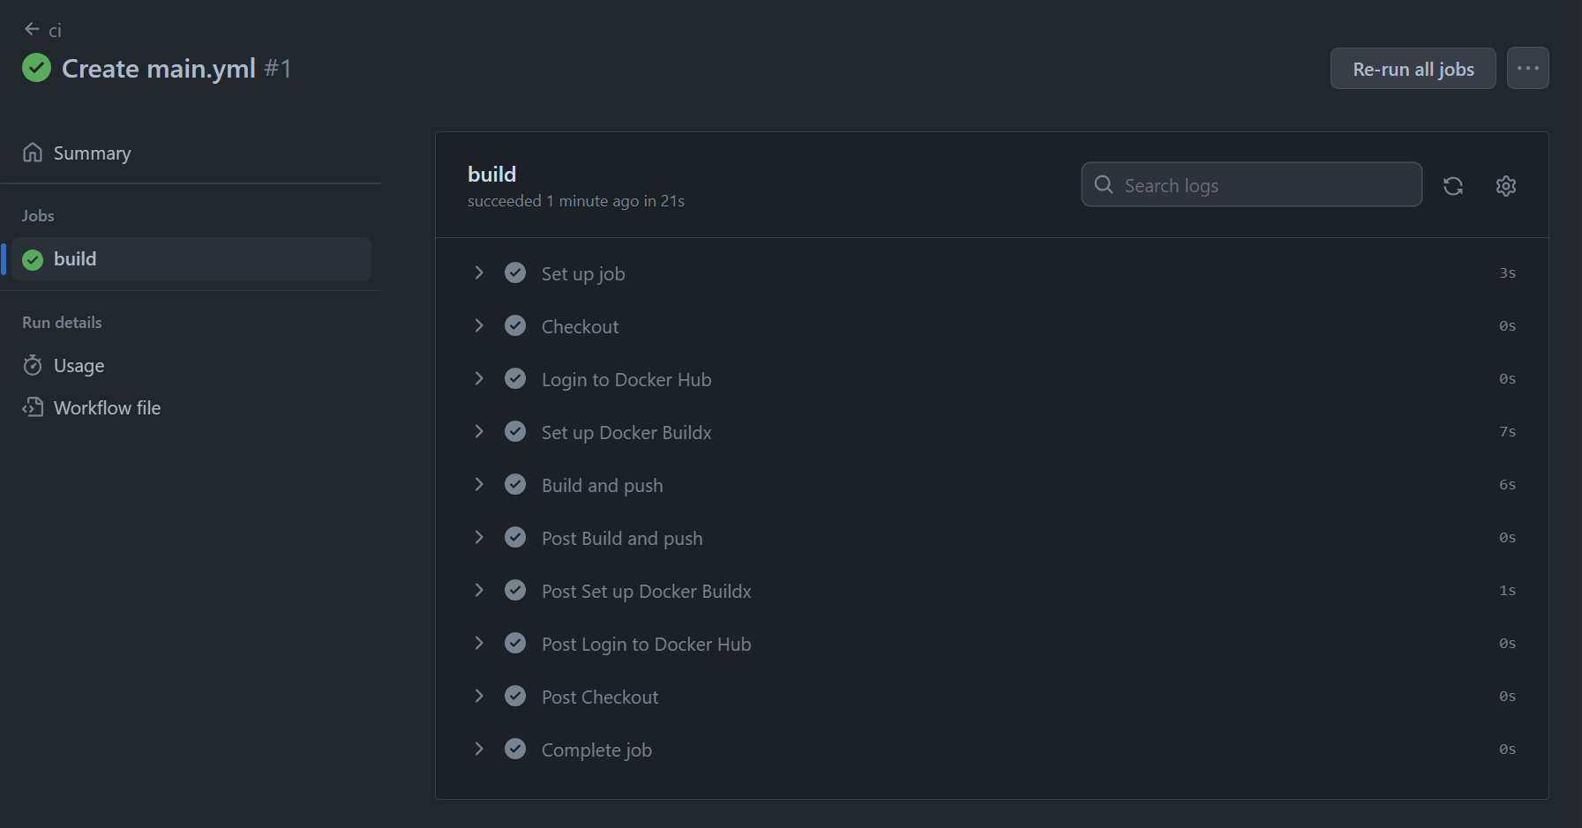

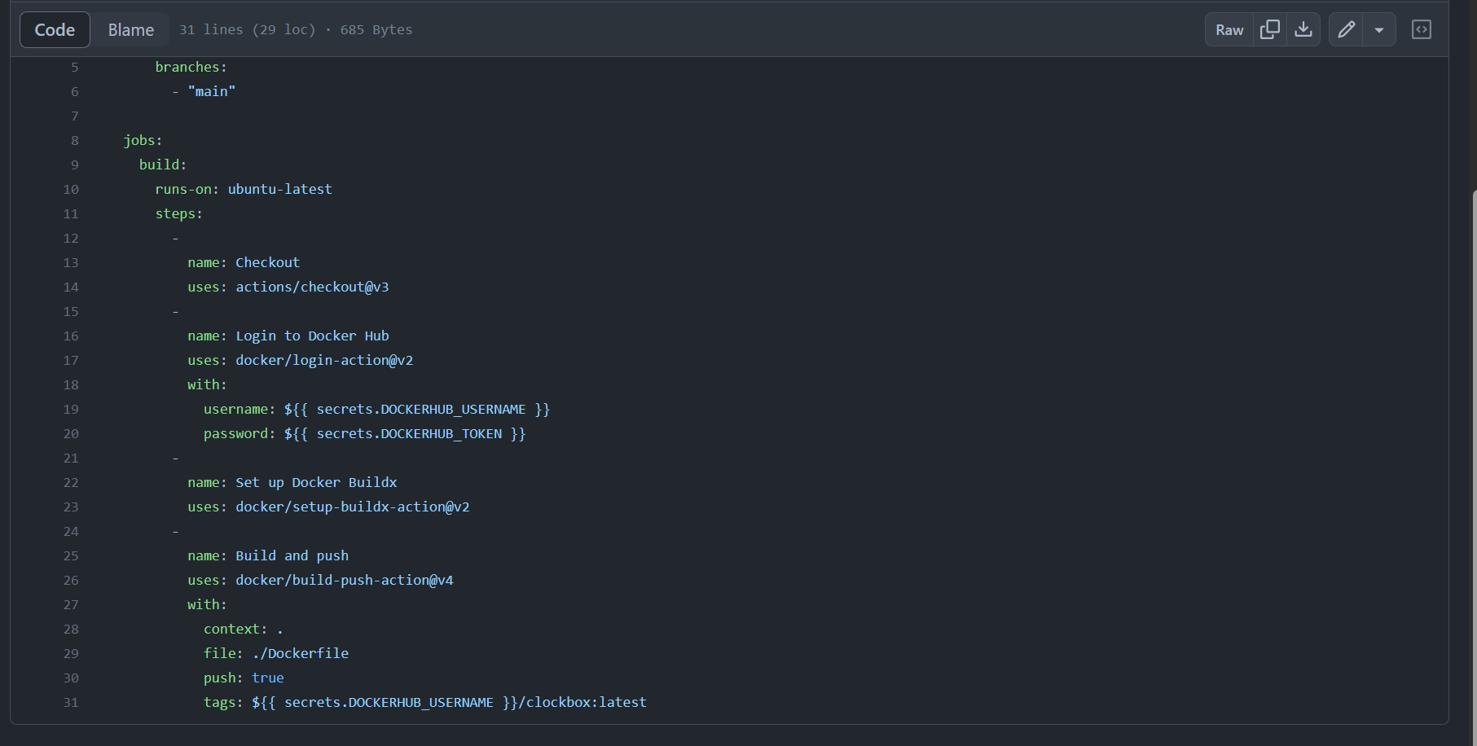

Step 9

Create Web App on Azure and Upload Docker image

1)Select Docker Container

2)Select region as west US 3

3)Select OS as Linux

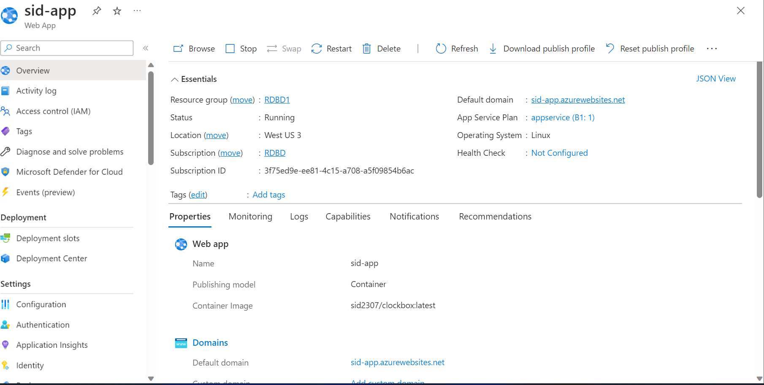

4)Input the image and tag from docker hub

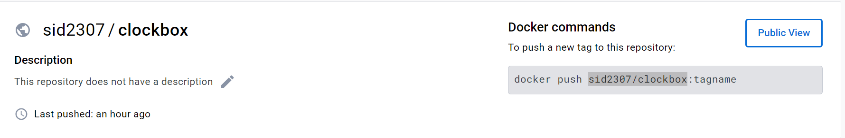

5)click on sid-app.azurewebsites.net

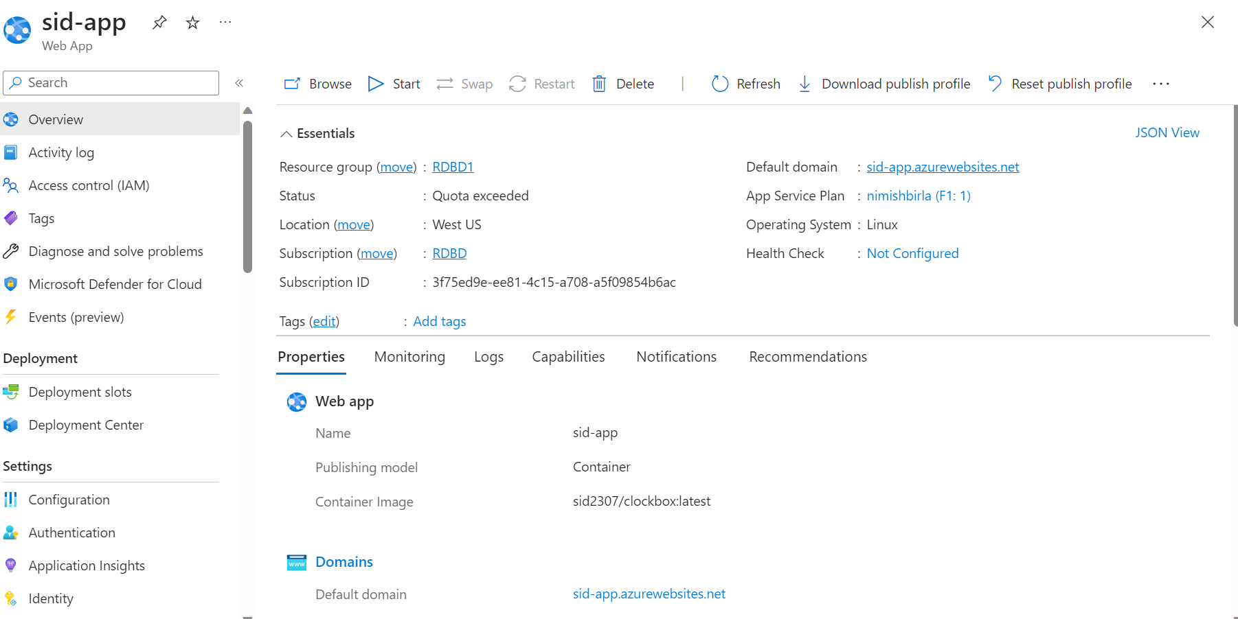

6)Output

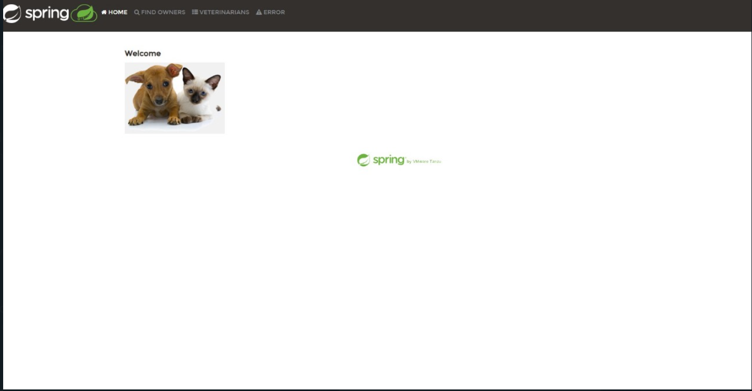

While installing maven we encountered our machine has java 11 but we have to install java 17